**Implementation of Decision Tree Classification using CHAID.**

Block Diagram:

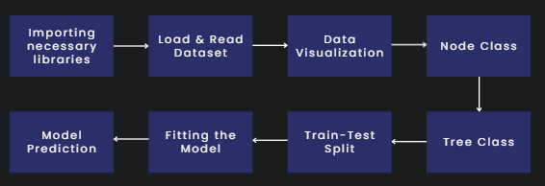

* Import numpy
* Build class to represent a node in the decision tree
* Splits the node into two child nodes using the CHAID algorithm (def split_node)
* Define chi-squared statistic using the CHAID algorithm.(def chaid)
* Predicts the class label for a single instance.(def predict 🡪 x)
* Define decision tree: a class to represent it & builds the decision tree using the CHAID algorithm.